Secure Password Manager
User Training Guide
Bitwarden (self-hosted) at https://vault.lab.local
Prepared by: [Rishi Ponkya] Date: 30 October 2026

Contents
Contents 1
1. About this guide 1
How your passwords are protected 1
2. Using passwords securely 1
2.1 Choose a strong master password 1
2.2 Let the generator create site passwords 1
2.3 Good habits 1
3. Setting up two-step login (MFA) 1
3.1 Before you start 1
3.2 Turn it on 1
3.3 Signing in with a code 1
4. Connecting the desktop app and browser extension 1
4.1 Trust the server certificate (one-time, IT staff) 1
4.2 Desktop app 1
4.3 Browser extension 1
5. Saving and filling passwords 1
5.1 Save a new login 1
5.2 Fill a saved login 1
5.3 Items sync between devices 1
6. Backing up and restoring your vault 1
6.1 Create an encrypted backup 1
6.2 Check that the backup is encrypted 1
6.3 Restore from a backup 1
6.4 Server backups (IT staff) 1
7. If something goes wrong 1
What IT can see 1
8. Quick reference 1

1. About this guide
This guide shows staff how to use the company password manager safely. It covers choosing a strong master password, turning on two-step login, connecting the browser extension and desktop app, saving and filling passwords, backing up and restoring the vault, and what to do when something goes wrong.
The steps were tested on a lab deployment of Bitwarden running on our own server at https://vault.lab.local. The screenshots come from that test. Wherever you see a grey box, a screenshot belongs there.

How your passwords are protected
- Encryption: everything in your vault is encrypted with AES-256 on your device before it reaches the server. The server only stores scrambled data.
- Key derivation: your master password is stretched with PBKDF2-SHA256 (600,000 rounds in our test) to create your encryption key. The master password itself is never stored.
- Tamper detection: each encrypted item carries an HMAC, so changed or corrupted data is detected.
- Two-step login: a code from an authenticator app is needed on top of your master password.
Important: Nobody, including the administrator, can read or reset your master password. If you forget it, your vault cannot be recovered. Section 7 explains how to avoid this.

2. Using passwords securely

2.1 Choose a strong master password
- Use a passphrase of at least 14 characters, made of several unrelated words, with a number or symbol if you like.
- Never use it anywhere else. It is the only password you need to memorise.
- Do not use names, birthdays or anything that appears on your social media.
- Write it down once and keep the paper somewhere locked and private, such as a safe. Do not store it in a file on your computer.

2.2 Let the generator create site passwords
- Open the vault, then choose Tools > Generator (or click the generator icon inside the extension).
- Set a length of at least 16 characters and keep letters, numbers and symbols turned on.
- Copy the result, or use the generator button while saving a new login so it is stored automatically.

2.3 Good habits
- One unique password per site. If one site is breached, the others stay safe.
- Do not type passwords into chat, email or documents. Use the vault or Bitwarden Send.
- Lock the vault when you leave your desk (avatar > Lock now).
- Only enter your master password on https://vault.lab.local, the desktop app or the official extension. Check the address before you type.
- Run the password health report regularly to find weak or reused passwords, and change them.
Note: The health reports (Reports in the left menu) may need an organisation licence on a self-hosted server. If they are locked, check weak and reused passwords by hand.

3. Setting up two-step login (MFA)
Two-step login asks for a six-digit code from an authenticator app each time you sign in on a new device. We tested with FreeOTP. Authy or any app that supports standard time-based codes also works.

3.1 Before you start
- Install FreeOTP (or another authenticator) on your phone.
- Set your phone to use automatic date and time. Codes are time-based and fail if the clock is wrong.

3.2 Turn it on
- Sign in to the web vault at https://vault.lab.local.
- Go to Settings > Security > Two-step login.
- Choose Authenticator app > Manage, then enter your master password.
- In FreeOTP, tap the scan icon and scan the QR code shown on screen.
- Type the six-digit code from FreeOTP into the box and click Turn on.
- Close the dialog, then open Settings > Security > Two-step login > View recovery code and save the recovery code.
Insert screenshot here
P3 evidence: MFA setu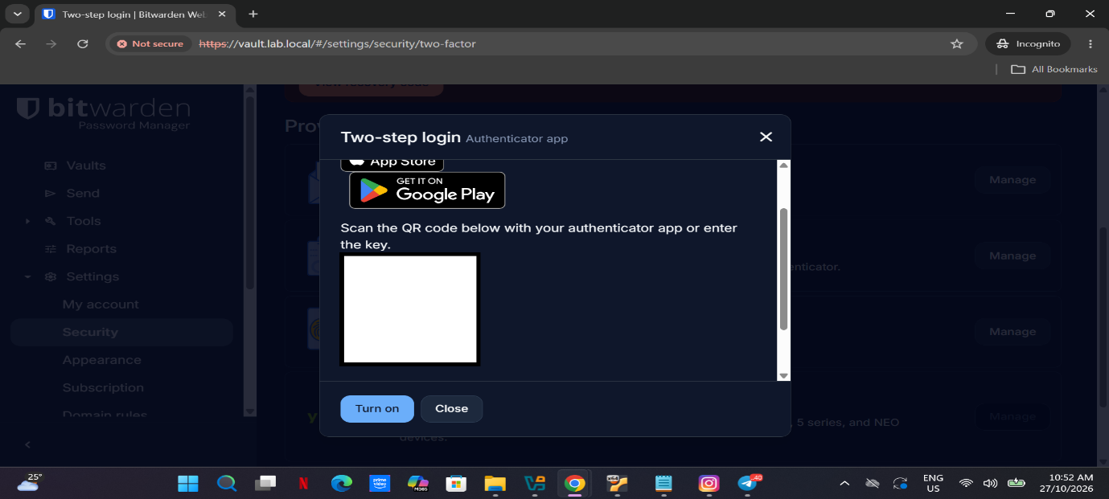p screenshot (QR code screen, QR hidden)
Figure 1. Authenticator app setup. Blur the QR code before sharing.
Warning: Store the recovery code offline, apart from your phone. If you lose the phone and the recovery code, you are locked out. In our lab, one account was lost this way.

3.3 Signing in with a code
After you enter your master password, Bitwarden asks for the code. Open FreeOTP, read the current six-digit code and type it in before it changes.

4. Connecting the desktop app and browser extension
Our company server is self-hosted, so each app must be pointed at it. If the login screen says Accessing: bitwarden.com, you are on the public cloud and your company account will not work.

4.1 Trust the server certificate (one-time, IT staff)
The lab server uses a self-signed certificate. IT imports it into the Windows Trusted Root store, then staff fully restart Chrome. The certificate must include the name vault.lab.local in its Subject Alternative Name, otherwise browsers and the desktop app reject it.
Insert screenshot here
P6-02a-cer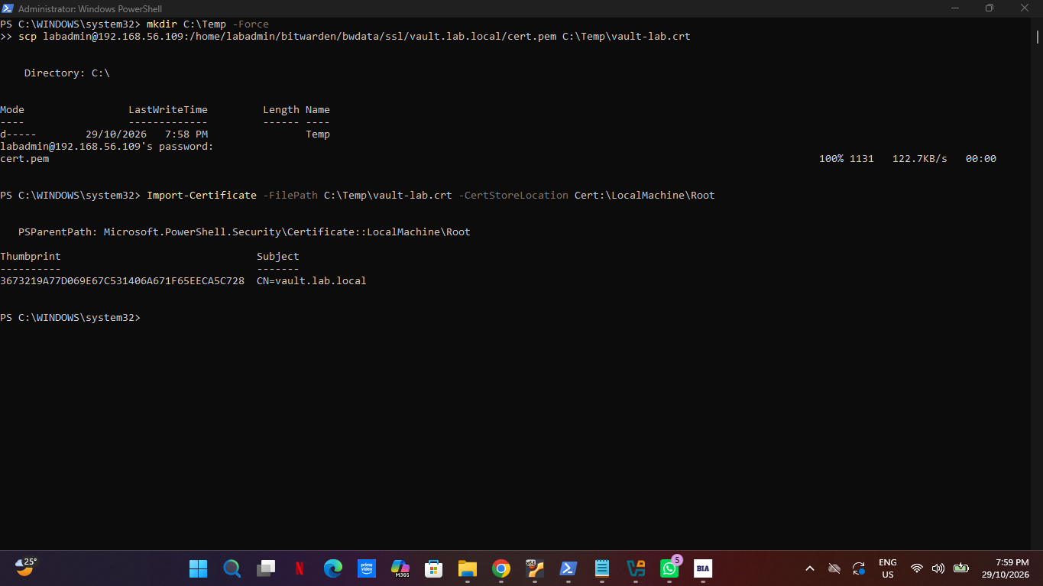t-trusted.png
Figure 2. Certificate imported into the Trusted Root store (IT step).
Insert screenshot here
P6-02b-cert-tru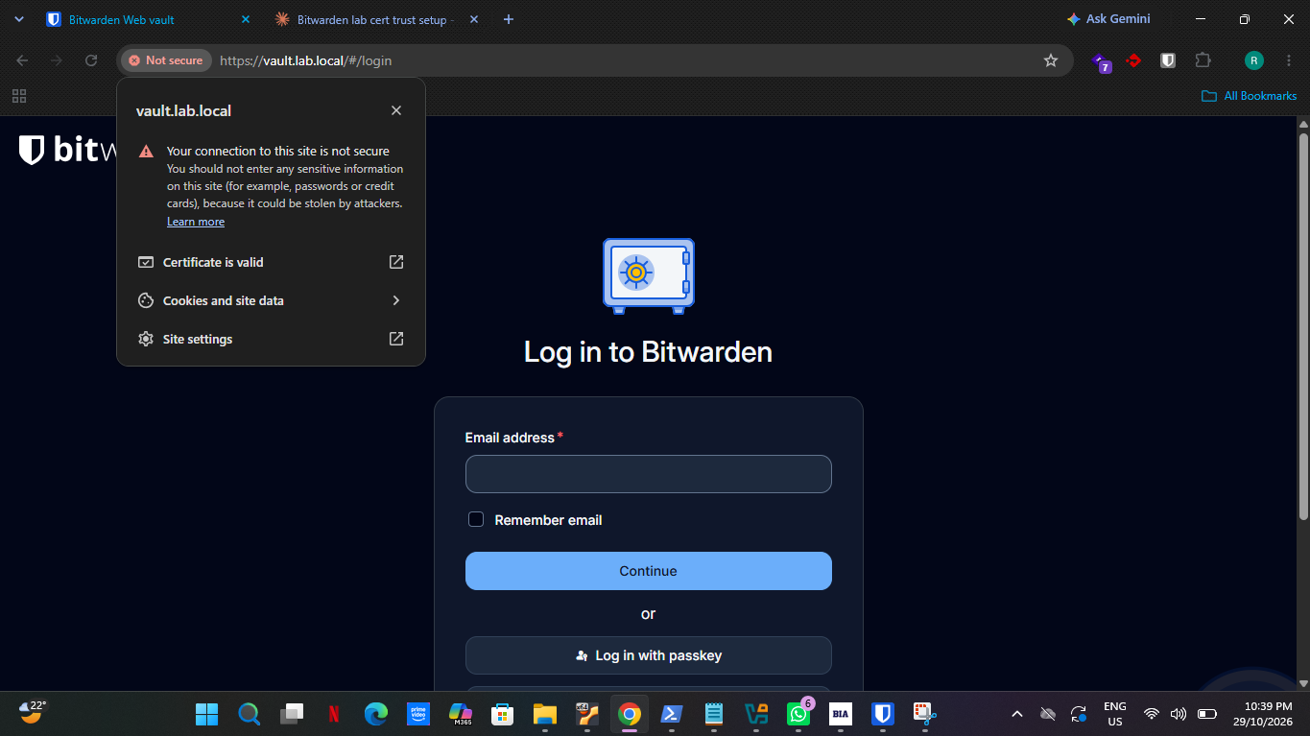sted-browser.png
Figure 3. Chrome reports the certificate as valid.

4.2 Desktop app
- Install the Bitwarden desktop app and open it.
- On the login screen, click the Accessing line at the bottom and choose Self-hosted.
- Enter https://vault.lab.local as the Server URL, then click Save.
- Check the bottom line now says Accessing: self-hosted.
- Enter your email, master password and the two-step code.
Insert screenshot here
P6-01-des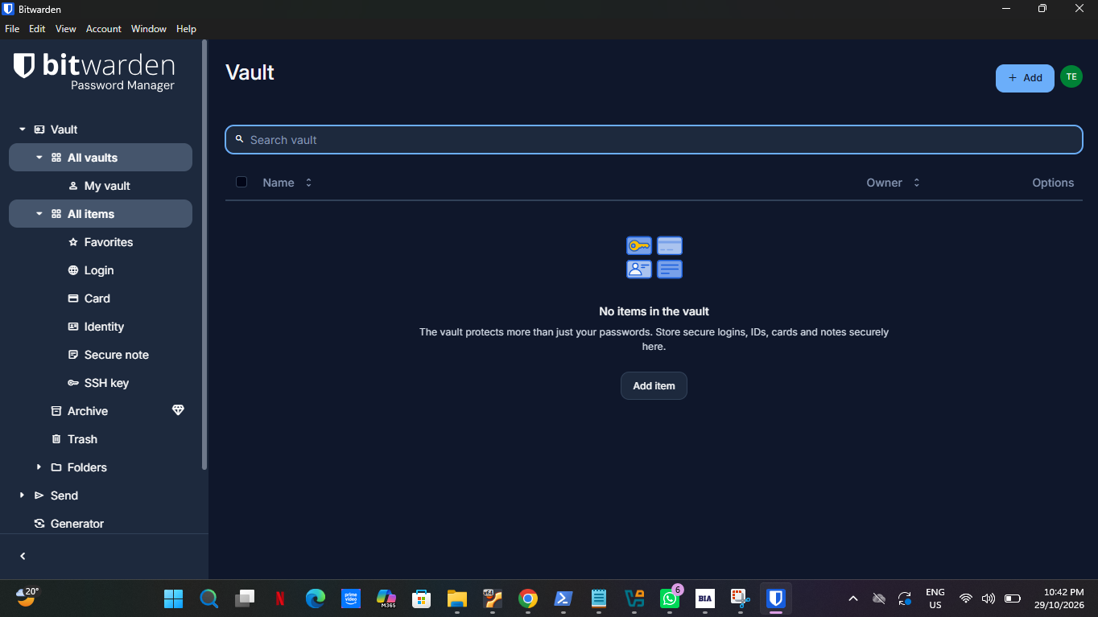ktop-login.png
Figure 4. Desktop app signed in to the company server.

4.3 Browser extension
- Install Bitwarden Password Manager from the Chrome Web Store.
- Click the extension icon, then the Accessing line, and choose Self-hosted.
- Enter https://vault.lab.local and click Save.
- Sign in with your email, master password and two-step code.
Insert screenshot here
P6-03-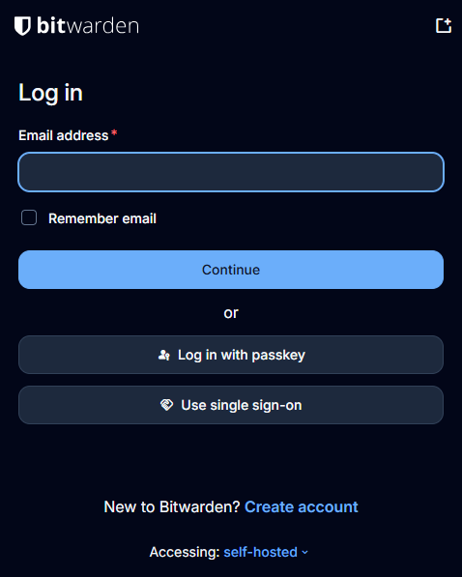extension-setup.png
Figure 5. Extension set to Accessing: self-hosted.
Insert screenshot here
P6-04-exten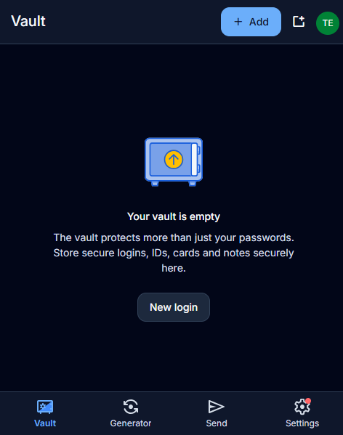sion-login.png
Figure 6. Extension signed in and unlocked.
If you see "Failed to fetch": the app cannot reach or trust the server. Check the server URL, close all Chrome windows and reopen them, and quit the desktop app completely from the system tray before trying again. If it persists, contact IT.

Mobile (iOS and Android) and macOS were not tested in this lab. The steps are the same: install the app, choose Self-hosted, enter https://vault.lab.local, and install the company certificate on the device first.

5. Saving and filling passwords

5.1 Save a new login
- Sign in to a website as normal.
- When Bitwarden shows the Add login prompt, check the name and username, then click Save (or Save and fill).
Insert screenshot here
P6-06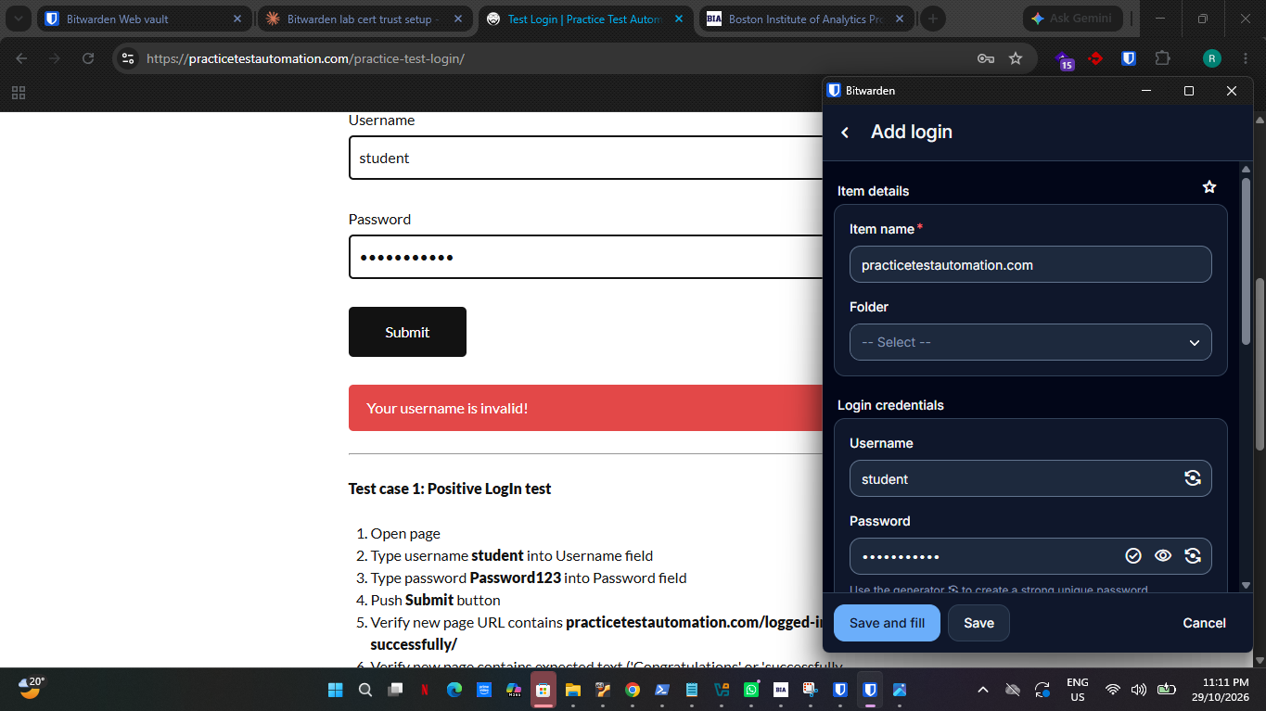-autosave.png
Figure 7. The extension offers to save a new login.

5.2 Fill a saved login
- Go to the site's login page.
- Click the Bitwarden icon. The matching login appears under Autofill suggestions.
- Click the entry to fill the username and password, then submit.
Insert screenshot here
P6-0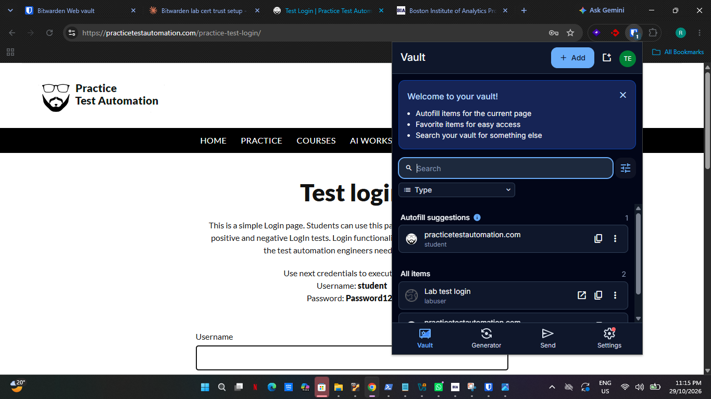7-autofill.png
Figure 8. Autofill suggestion for the current site.
Suggestions only appear if the saved item's web address matches the page. If nothing shows, open the item and add the site address under its website field.

5.3 Items sync between devices
A login saved in the extension appears in the desktop app after a short sync (File > Sync vault forces it).
Insert screenshot here
P6-05-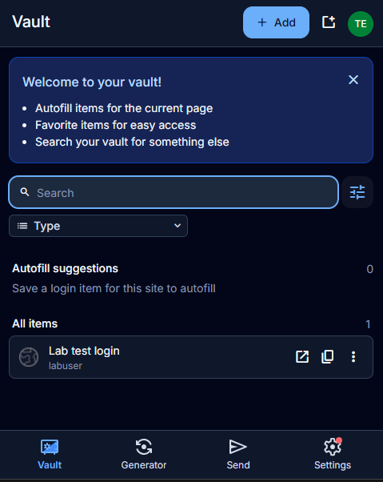sync-extension.png
Figure 9. Item saved in the extension.
Insert screenshot here
P6-05-sync-desktop.png
Figure 10. The same item in the desktop app.

6. Backing up and restoring your vault
Make an encrypted backup of your vault from time to time, and before any major change. This was tested end to end: export, delete an item, restore, and confirm the item came back.

6.1 Create an encrypted backup
- In the web vault, open Tools > Export.
- Set File format to .json (Encrypted). Never choose plain .json or .csv: those files contain your passwords in readable text.
- Set Export type to Password protected. This lets you restore the file even on a different account or server. "Account restricted" files can only be restored into the same account.
- Enter a strong file password, confirm it, then click Export and enter your master password.
- Move the file out of the Downloads folder to a protected location, such as an encrypted drive. Keep the file password somewhere separate from the file.
Insert screenshot here
P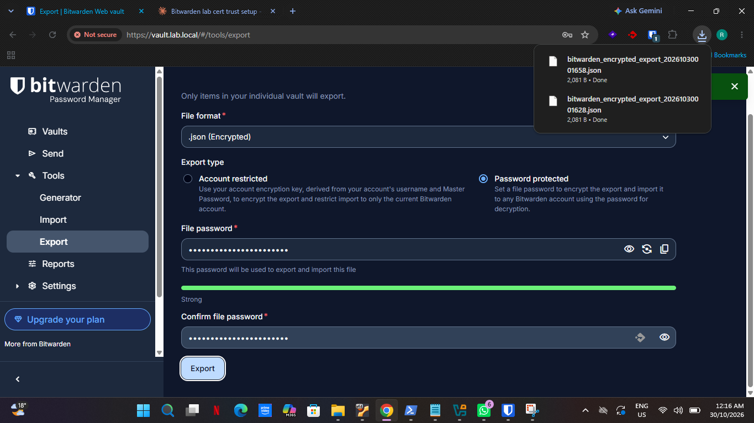8-01-export-dialog.png
Figure 11. Export dialog: .json (Encrypted), password protected.

6.2 Check that the backup is encrypted
Open the file in Notepad. You should see "encrypted": true and "passwordProtected": true, followed by key-derivation settings (kdfType 0 means PBKDF2-SHA256, with 600,000 iterations) and an unreadable block of data. No usernames or passwords should be readable.
Insert screenshot here
P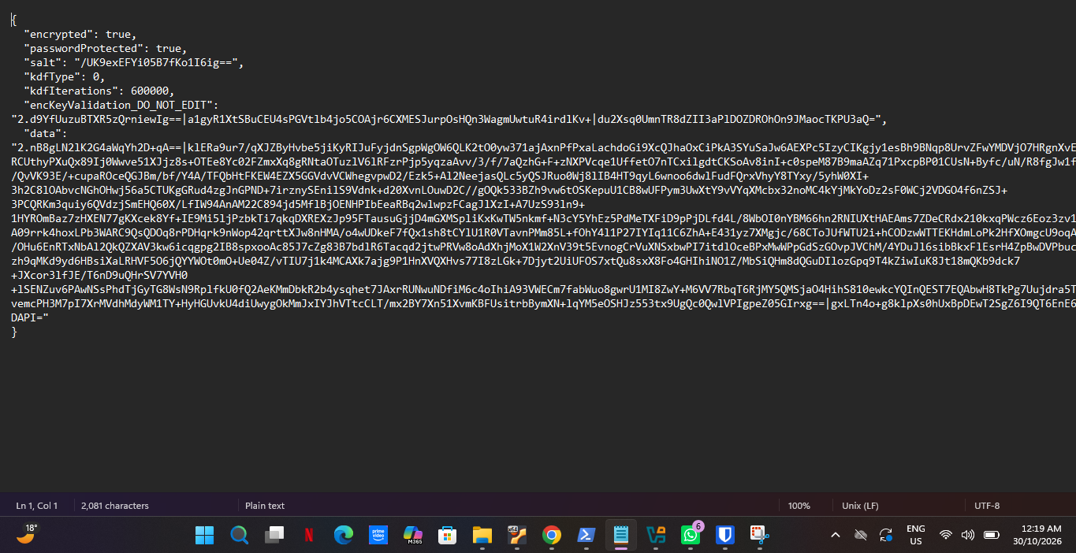8-02-encrypted-file.png
Figure 12. Encrypted backup file opened in Notepad.

6.3 Restore from a backup
- Go to Tools > Import data.
- Set Import to My vault and File format to Bitwarden (json).
- Choose your backup file and click Import data.
- When asked, enter the file password, not your master password. This is the most common mistake.
- Click OK, then check that your items are back.
Insert screenshot here
P8-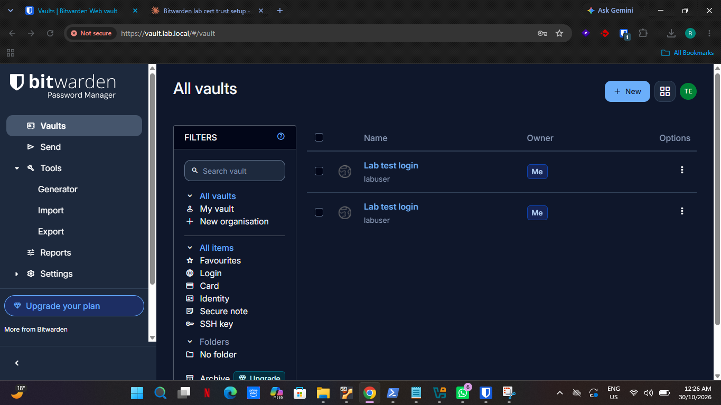03-item-deleted.png
Figure 13. Test item deleted from the vault (simulated data loss).
Insert screenshot here
P8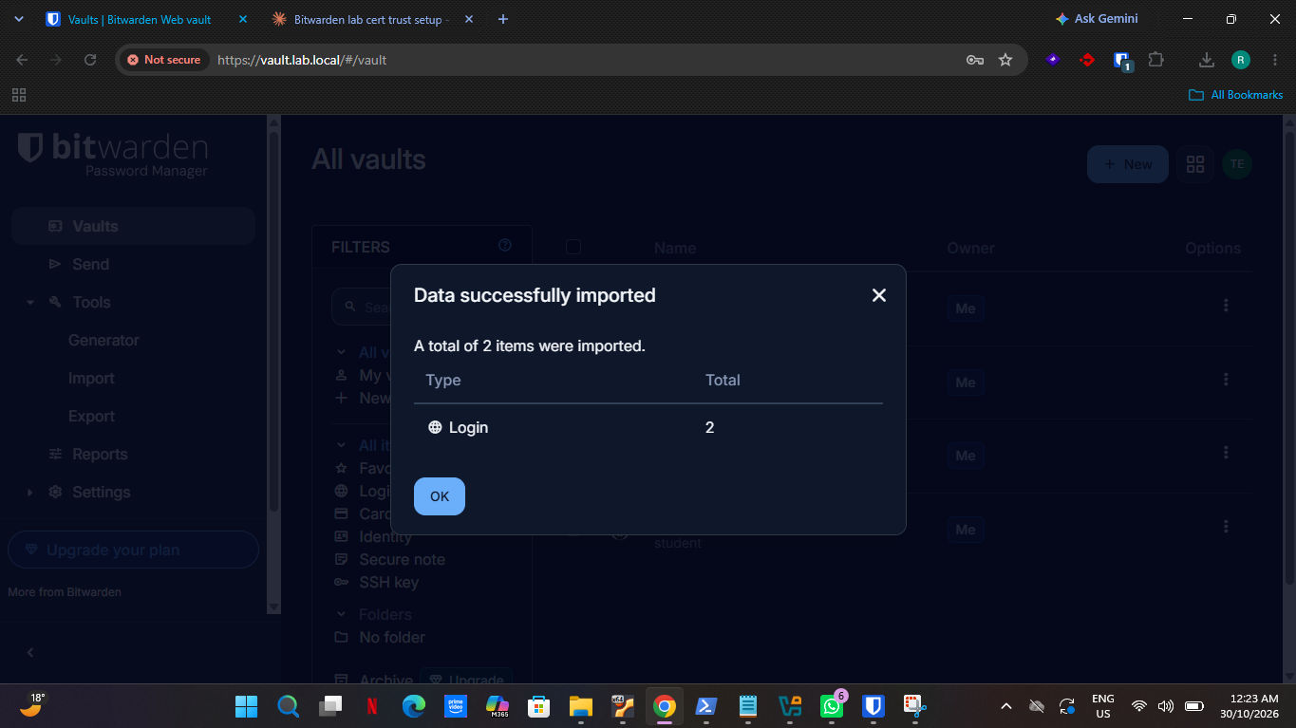-04-import-restore.png
Figure 14. Import completes successfully.
Insert screenshot here
P8-05-i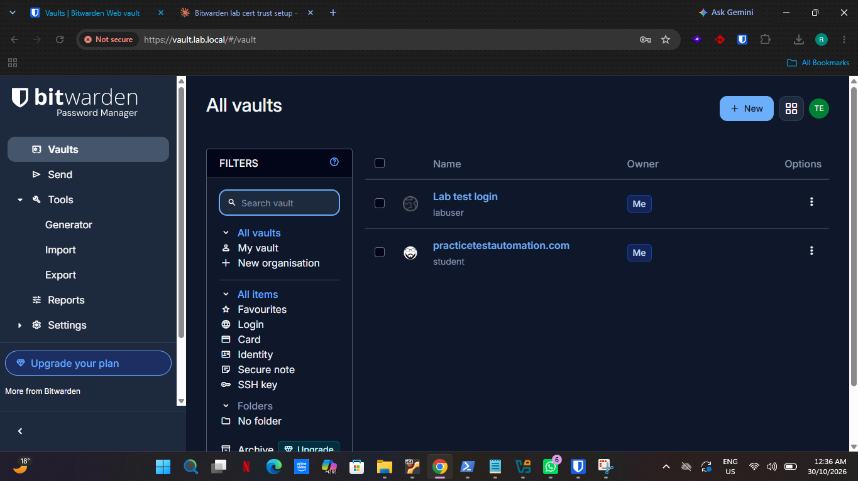tem-restored.png
Figure 15. The deleted item is back after the restore.
Tip: Import adds every item in the file and does not merge. If items still existed, you will see duplicates. Delete the extra copies afterwards.

6.4 Server backups (IT staff)
IT also backs up the server database (bitwarden.sh updatedb creates a backup under bwdata/mssql/backups). Copy these backups off the server and encrypt them. They hold the encrypted vault data for all users.

7. If something goes wrong
Problem | What happens | What to do
Forgot master password | The vault cannot be recovered. There is no reset, because the server never has your key. | Try your password hint if one was set. Otherwise restore from an encrypted backup into a new account. Prevent this by keeping the password stored safely offline.
Lost phone or authenticator | You cannot pass the two-step check. | Use your saved recovery code to sign in, then set up two-step login again on the new phone.
Lost both phone and recovery code | You are locked out. | Restore from a backup into a new account and set up two-step login again.
Wrong password too many times | Failed logins are logged with your user ID and IP address. | Wait, then try again. Tell IT if you did not make the attempts.
"Failed to fetch" error | The app cannot reach or trust the server. | Check the server URL and that the certificate is trusted, then restart the app and browser.
Suspect your password was leaked | Attackers may use it. | Change it at once on that site, then update the vault entry.

Lab finding: During testing, an account was lost because its master password was forgotten. This confirms why the recovery code and a stored encrypted backup matter. In a company with the Enterprise plan, an administrator can enable account recovery, but it needs an organisation licence.

What IT can see
Server logs record logins, failed logins (with user ID and IP address), and item create, edit and delete requests. They never show your passwords or vault contents. Organisation event logs, which give per-user audit trails, need an organisation licence.

8. Quick reference
Do | Do not
Use a long, unique master password | Reuse your master password anywhere
Turn on two-step login and save the recovery code offline | Keep the recovery code on the same phone
Check the address is https://vault.lab.local before typing | Enter your master password on links from email
Export as .json (Encrypted), password protected | Export plain .json or .csv, or leave exports in Downloads
Lock the vault when you step away | Share passwords over chat or email
Use the generator for new passwords (16+ characters) | Reuse passwords across sites

Support: contact IT at [IT contact details].

